About passive sampling method for mercury

Below is an overview of the passive sampling of mercury that we are currently working on.

1.Material
[For passive sampling]

Passive tube (porous polyethylene tube
(length approx. 50mm))
Gold amalgam collection material

Support stand (tripod, etc.)

Passive tube

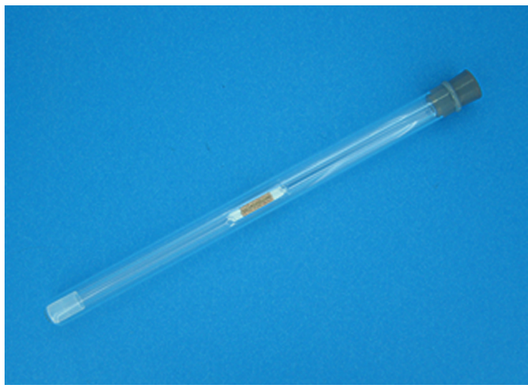[For active sampling (official method for monitoring hazardous air pollutants)]
Sampling tube (gold amalgam collection material)
mini pump
hose
Support stand (tripod, etc.)
Sampling tube

[measuring device for Mercury concentration]
Airborne mercury measuring device WA-5A
(manufactured by Nippon Instruments Co., Ltd.)
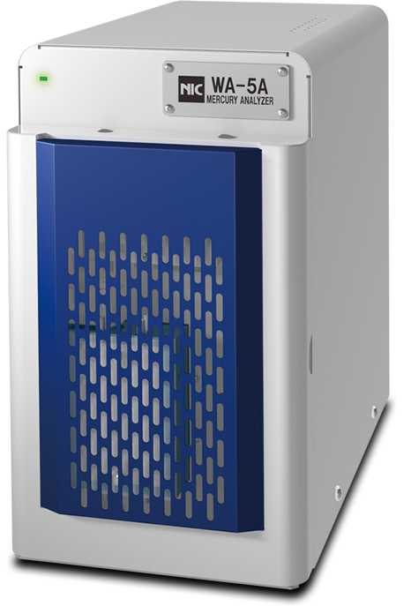

2. Sampling method
①To reduce blanks, the collection material packed in a quartz tube is heat-treated
before sampling.
②Take out the collection material from the quartz tube and put it into the passive tube.
③Store the passive tube in an aluminum bag until sampling.
④At the sampling point, set up the passive tube using a support such as a tripod. (Photo 1)
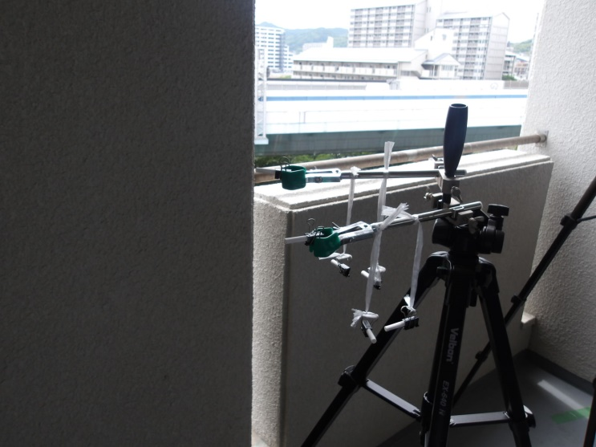
Photo 1
⑤Leave it for a few days to a few weeks
⑥After collecting the tube, take it back to the analysis room, fill the quartz tube with the collection material again, and quantify it using a measuring device.
３．Calculation of mercury concentration in the atmosphere
With passive sampling, the amount (mass) of mercury adsorbed on the collection material during the collection period can be determined, but in order to estimate the atmospheric concentration, conversion based on the sampling rate is required. Therefore, it is necessary to measure passive sampling and active sampling (collection using a pump) in parallel in advance to determine the sampling rate.
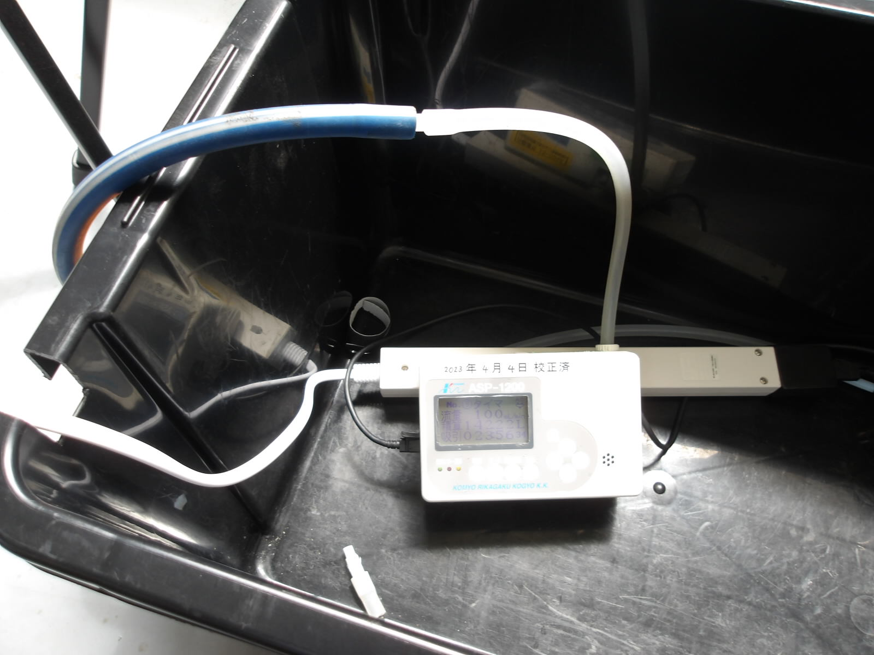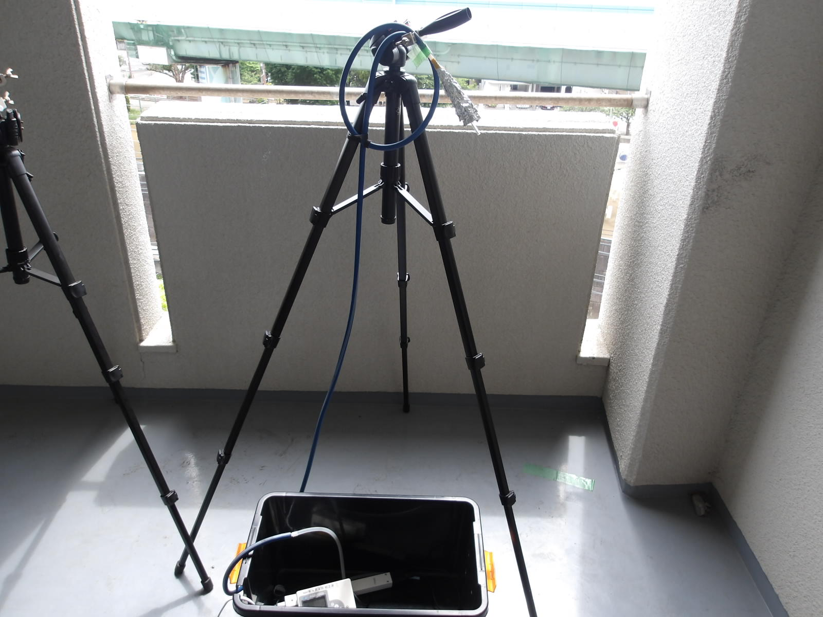

Active sampling
atmospheric concentration
Ｃ(ng/m3)＝（Ws-Wｂ）/（ＳＲ×Ｔ）
Ｗｓ：Amount of mercury collected by the collection
material of one passive sampler (ng)
Wb：blank value(ng)
SR：sampling rate（ng/m3・day）
T：sampling time（day）

